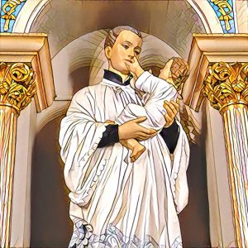**St. Stanislaus Kostka Parish**

**8 St. Ann Street, Hamilton, ON L8L 6P8; Tel: 905-544-0726**

[**ststanislaushamilton@hamiltondiocese.com**](mailto:ststanislaushamilton@hamiltondiocese.com)

**Forma Rejestracyjna do I Komunii Świętej**

**First Reconciliation & First Eucharist Request Form 2025-2026**

***Dear Fr. Marian Gil OMI:***

***Drogi O. Marianie,***

|  |  |
| --- | --- |
| **☐** | *I/we wish for my/our child to receive the sacraments of First Reconciliation and First Eucharist at St. Stanislaus Kostka Parish.* ***Please complete sections A & B and bring the completed form to the church or email to our parish office by June 30th, 2025*** |
|  | ***Chcielibyśmy, aby nasze dziecko uczestniczyło w programie przygotowującym do I Komunii św. w parafii św. Stanisława Kostki w Hamilton. Proszę wypełnić ten formularz i przynieść go do zakrystii lub przesłać emailem na adres parafii do 30 czerwca, 2025 roku.*** |

**Section A – please print**

|  |  |  |  |
| --- | --- | --- | --- |
| Child’s name: |  | School: |  |
|  |  |  |  |
|  |  |  |  |
|  | *Signature of parent/guardian* |  | *Signature of parent/guardian* |

**Section B – please print**

|  |  |  |  |  |  |  |
| --- | --- | --- | --- | --- | --- | --- |
| Child’s address |  | | | | Postal code |  |
| Phone |  | | Home email |  | | |
| Date of birth |  | | | | | |
| Current parish/place of worship | |  | | | | |

|  |  |  |  |  |  |  |
| --- | --- | --- | --- | --- | --- | --- |
| Mother’s full birth name |  | | | | Religion |  |
| Contact information  same as above ☐ or | Address |  | | | | |
| Phone |  | Email |  | | |

|  |  |  |  |  |  |  |
| --- | --- | --- | --- | --- | --- | --- |
| Father’s name |  | | | | Religion |  |
| Contact information  same as above ☐ or | Address |  | | | | |
| Phone |  | Email |  | | |

**Child’s Baptismal Information**

|  |  |  |  |  |
| --- | --- | --- | --- | --- |
| ☐ My/our child is baptized. *(Please provide the baptismal information below. A copy of the Baptism certificate will be required if the child was baptized at a church other than St. Stanislaus Kostka Parish.*  ☐ My/our child is not baptized. Please contact me/us to discuss Baptism for my/our child. | | | | |
| Date of Baptism |  | | Religion |  |
| Place of Baptism | Name of Church |  | | |
| Complete address |  | | |